|  |  |  |
| --- | --- | --- |
| **LAB 321Assignment** | **Type:** | **LongAssignment** |
| **Code:** | **J3.L.P0028** |
| **LOC:** | **500** |
| **Slot(s):** | **15** |

**Title:** Salon Nails & Beauty

**Background**

### Your girlfriend want to open a Salon Nails & Beauty shop online .

Complete this assignment to help her as soon as possible ☺

Reference site:<http://us-123-beauty.simplesite.com/>

**Program Specifications**

Program a web site to introduce your Salon Nails & Beauty shop online, detail functions of this website is described below

**Features:**

This website contains 3 main functions

* Function 1 : Home page : ( see PIC 01)
  + Display introduction entry and top 2 entry sort by published date ,
  + Each entry contains
    - Entry name
    - Description picture
    - Entry description
* Function 2 : Prices list ( PIC 02)
  + Print out detail services prices
* Function 3 : Contact ( PIC 03)
  + Display contact information

You do not need to write interface for admin control panel, you can add data manually (use SQL SERVER Management studio).

Note: All data must be load from database, not hard code in page.

***Expectation of User interface:***

Pic 01 : Home Page

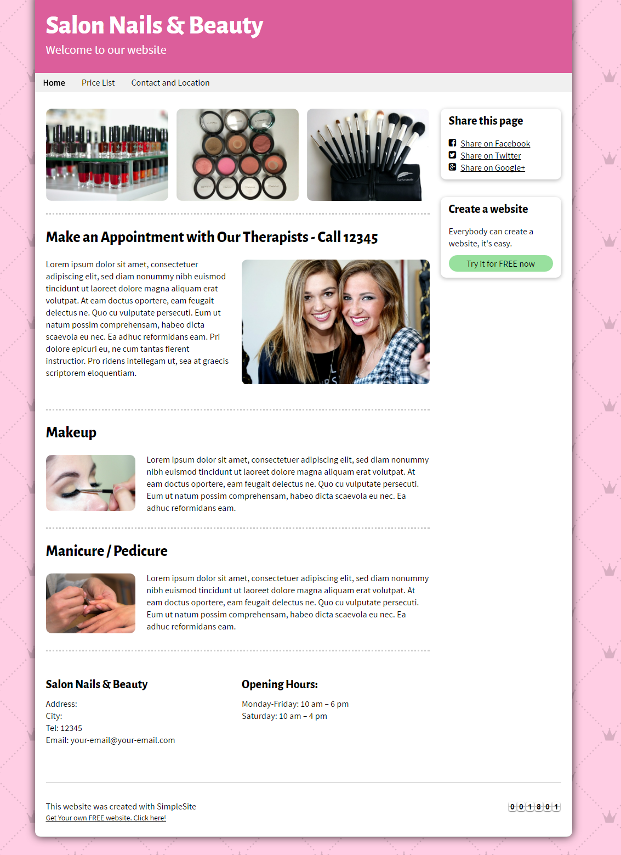

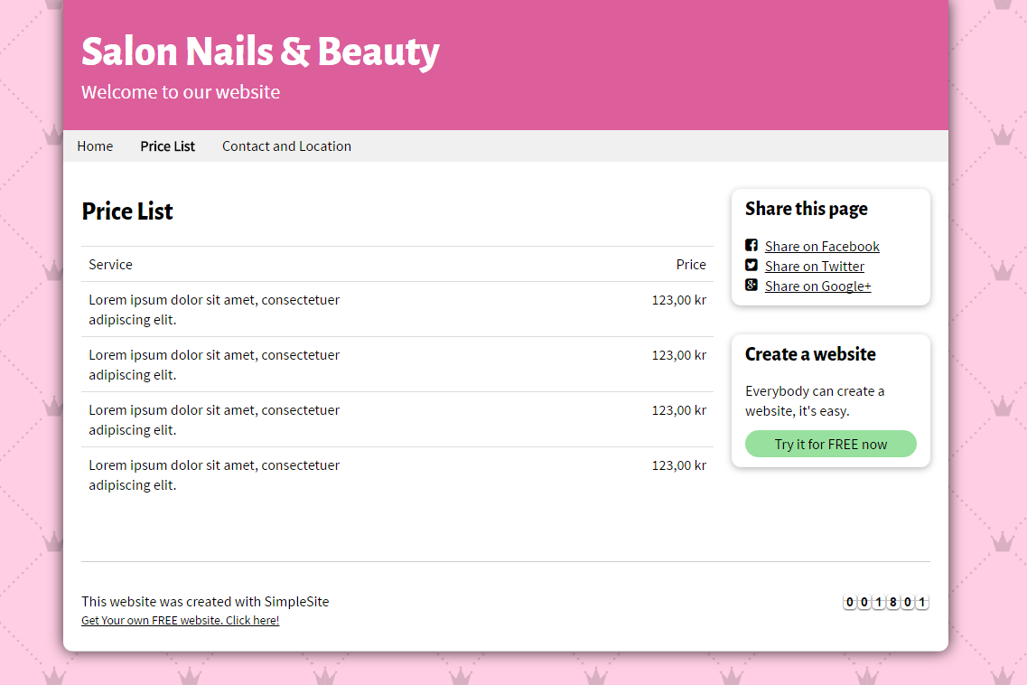

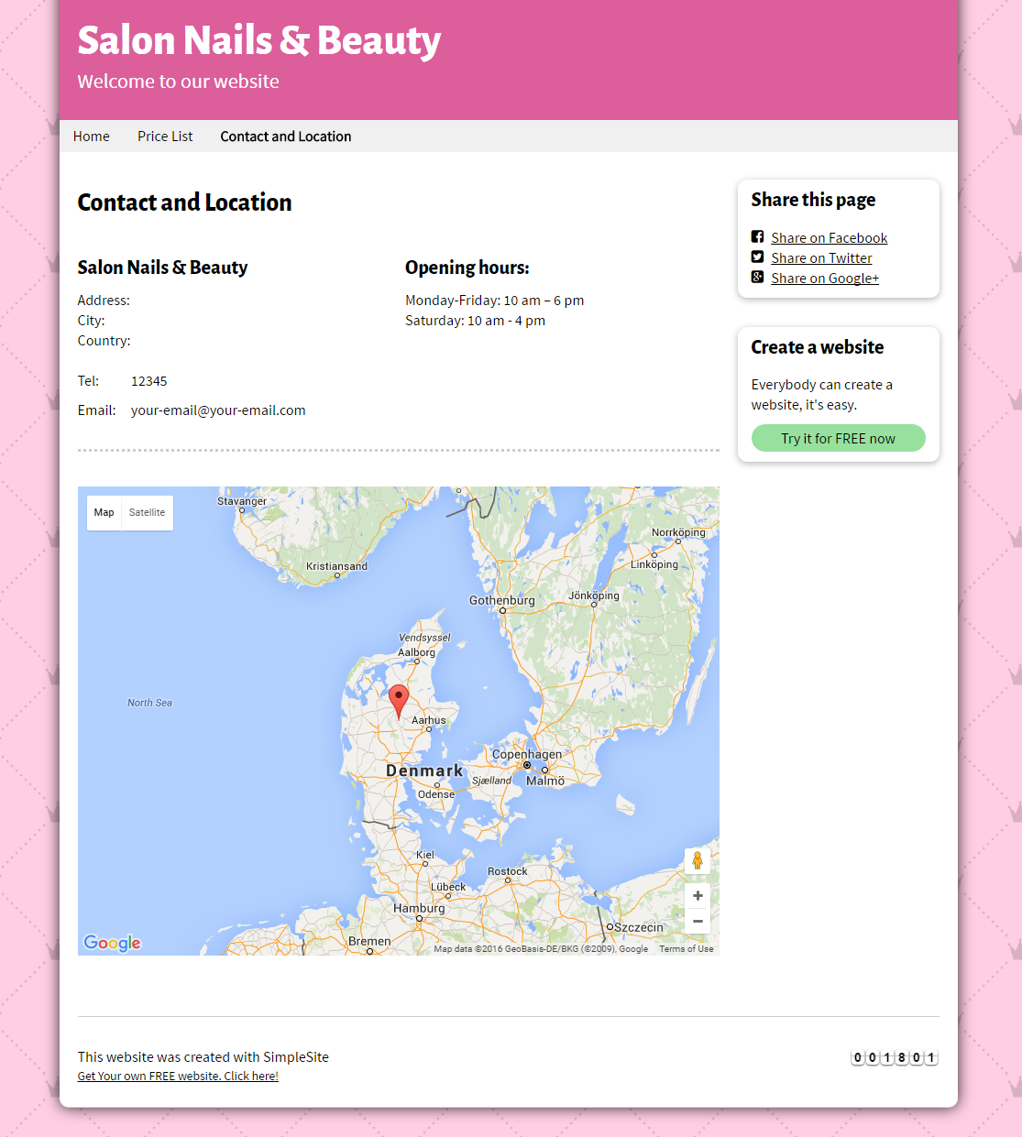

**Guidelines**

* Step 1 : Create web layout
* Step 2 : Create prototype
* Step 3 : Design database base on created prototype
* Step 4 : Code & Test